**Cart management**

The architecture that is intended to be achieved in given below:

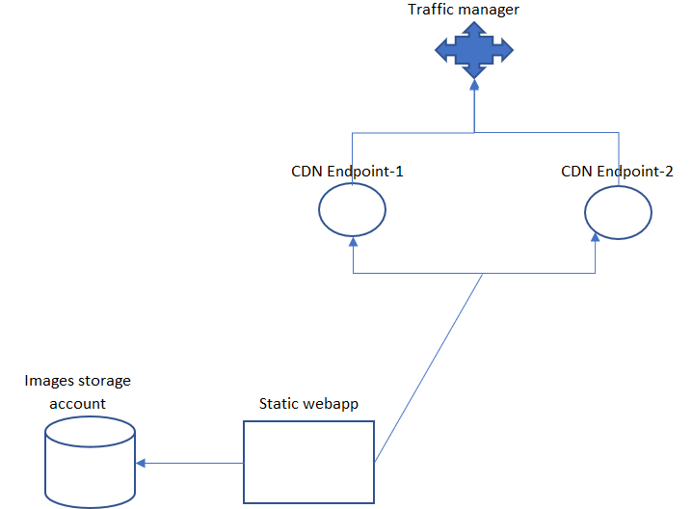

1. Create storage account for images upload
2. Create static webapp that is deployed via continuous integration to GitHub repository
3. Test the webpage load and successful load of images from storage account
4. Create 2 CDN endpoints that will point to static webapp
5. Test the website load via CDN end points separately
6. Create Traffic manager with Priority based routing pointing to 2 CDN end points